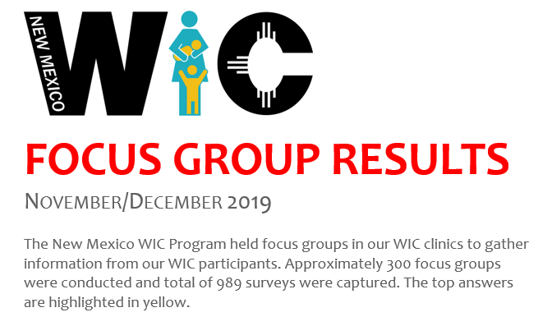
Question: How far in advance would you like to be reminded of an appointment?
- 1 day before your appointment
- 2-3 days before your appointment (52% of those surveyed)
- 4-5 days before your appointment
- Other
Question: What is your preferred method of contact for appointment reminders?
- Text (89% of those surveyed)
- Email
- Phone call
- Other
Question: Do you use any nutrition-related or parenting app, or shopping apps?
- No (88% of those surveyed)
- Yes; If so, what did you like or not like about it
Question: NM WIC is trying to use better technology. We will have a lot more options regarding our services. Which of the following would benefit you as a WIC participant? (select up to THREE options)
- Getting your appointment done at a grocery store, farmer’s market, or community event.
- Scheduling your appointment online.
- Completing paperwork online so your appointment is shorter. (46% of those surveyed)
- More online options for completing Nutrition Education classes.
- Receiving text messages with Health/Nutrition tips. (54% of those surveyed)
- Receiving text messages with Nursing tips.
- Other
Question: Using your WIC EBT card has made… (please select all that apply)
- your shopping experience easier (64% of those surveyed)
- finding more food options easier
- shopping for WIC food faster
- your shopping experience more difficult/or slower; If so, why?
Question: What was the most challenging aspect of shopping with WIC? (select up to TWO options)
- Finding WIC approved foods at the store. (64% of those surveyed)
- Getting to a grocery store near you.
- Problems when checking out at the grocery store.
- Knowing your food balance on your WIC EBT card. (38% of those surveyed)
- Other
Question: What improvements would be helpful for you when shopping with WIC? (Select up to two options)
- Seeing more ‘WIC Approved’ stickers at the store. (84% of those surveyed)
- Order your WIC food online and picking up your order at the store.
- Viewing and keeping track of your benefits on a phone App. (56% of those surveyed)
- Getting your WIC appointment completed at the grocery store or a community event.
- Other
Question: What things do you think the WIC program could do to help people in your community learn more about the program? (Select all that apply, and give a short answer at the end)
- Perform Nutrition education and food demonstrations at events in your community.
- Post flyers at popular venues/areas in your community. (57% of those surveyed)
- Have a user-friendly website. (47% of those surveyed)
- What is one thing WIC can do to reach people in your community?
Question: What would keep people in your community from participating in the WIC program? (select all that apply)
- People in your community want WIC but don’t know they are eligible. (70% of those surveyed)
- Appointments take up too much time.
- Fear or concern about government programs. (39% of those surveyed)
- Limited food options. If selected, which foods would you like added to the WIC program?
- WIC clinic is too far.
- Other
Question: What would make the WIC program more appealing to people in your community? (select all that apply)
- If WIC used more interactive technology, such as: Apps, texting, and emailing. (68% of those surveyed)
- If WIC was more active in your community. If selected, do you have any suggestions?
- An improved website.
- Other
Question: What other services would be helpful for you as a WIC participant? (Select your top TWO choices).
- Being certified right at the grocery store or a community event.
- More advanced lactation/nursing support.
- Referrals to Income Support programs.
- An option to receive Nutrition education or lactation/nursing tips via text message.
- More options to complete your Nutrition classes online.
- Being able to schedule your appointments online. (34% of those surveyed)
- Having an interactive WIC app that allows you to view your benefits. (44% of those surveyed)
- Other

